2. BASIC EQUATIONS OF FLUID FLOW

Basic equations of flowing fluid
Mass balance: The rate of mass entering the flowing system equals that leaving as mass can neither be accumulated or depleted with in a flow system under steady conditions.
Continuity equation : Consider a stream tube as shown in figure 2.1.
Velocity, u_{a}
Density , ρ_{a}
Area, S_{a}
Velocity, u_{b}
Density , ρ_{b}
Area, S_{b}
Figure 2.1

Let the fluid enter at a point where the area of cross section of the tube is S_{a} and leaves where the area of cross section is S_{b}. Let the velocity and density at the entrance be u_{a} and ρ_{a} respectively and the corresponding quantities at the exit be u_{b} and ρ_{b}. Assume density in a single cross section is constant. Also assume that the flow through the tube is potential flow. Then the velocity u_{a} is constant across the area S_{a} and velocity u_{b} is constant across area S_{b}.
The mass of fluid entering and leaving the tube per unit time is
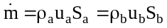
where m is the rate of flow in mass per unit time.
For a stream tube 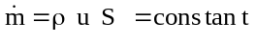
This equation is called the equation of continuity. It applies to both compressible and incompressible flows.
For incompressible flow, the above equation reduces to
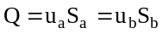
Average velocity: If the flow through the stream tube is not potential flow, the velocity ‘u_{a}’ and ‘u_{b}’ will vary from point to point across the area S_{a} and S_{b} respectively. Then it is necessary to distinguish between the local and average velocity.
The average velocity ū of the entire stream flowing through cross section ‘S’ is defined by ū
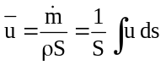
also equals the total volumetric flow rate of the fluid divided by the cross sectional area of the conduit. That is 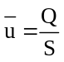where Q is the volumetric flow rate, m³/s. ū and u are equal only when the local velocity is the same at all points in area ‘S’.
The continuity equation when the velocity varies in a finite stream tube is 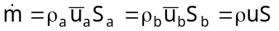
Mass Velocity: We know 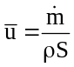 or this may be written as 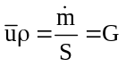. This equation defines mass velocity G, calculated by dividing the mass flow rate by the cross sectional area of channel, [unit kg/sm²]. The mass velocity ‘G’ can also be described as the mass current density or mass flux, where flux is defined generally as any quantity passing through an unit area in unit time. The average velocity ū can be described as the volume flux of the fluid.
Problems :
2.1. The diameters of pipe at the section 1 and 2 are 10 cm and 15 cm respectively. Find the discharge through the pipe if the velocity of water flowing through the pipe at section 1 is 5 m/s. Determine the velocity at section 2.
Data: Section 1 Section 2
D₁=10cm=0.1m D₂ = 15cm=0.15m
S₁ = (π/4)*D₁²=(π/4) 0.1² S₂ = (π/4)*D₂²=(π/4) 0.15²
= 0.007854m² = 0.01767 m²
v₁= 5 m/s
Discharge through the pipe is given by Q=S₁v₁ =0.007854 * 5 =0.03927m³/s.
From continuity equation for incompressible fluid (water)
v₁S₁ρ₁=v₂S₂ρ₂ ⇒ v₁S₁=v₂S₂
⇒ v₂=(v₁S₁)/S₂ = (0.00785*5)/0.01767 = 2.22 m/s.
2.2. A 30 cm pipe conveying water, branches into two pipes of diameters 20 cm and 15 cm respectively. If the average velocity in the 30 cm diameter pipe is 2.5 m/s, find the discharge in this pipe. Also determine the velocity in 15 cm pipe if the average velocity in 20 cm is 2m/s.
Data:
D₁ = 30cm = 0.3m | D₂ = 20cm = 0.2m | D₃ = 15cm = 0.15m
S₁=(π/4)*0.3²=0.07068 m² | S₂=(π/4)*0.2²=0.0314 m² | S₃=(π/4)*0.15²=0.01767 m²
V₁ = 2.5m/s  D₁ =0.3m  D₂ =0.2m  D₃ =0.15m | v₂ = 2m/s | v₃ = ?
Let Q₁,Q₂ and Q₃ are discharges in pipes 1, 2 and 3.
According to continuity equation
Q₁=Q₂+Q₃
Q₁ = S₁v₁₌ = 0.07068*2.5 = 0.1767 m³/s
Q₂ = S₂v₂₌ = 0.0314*2 = 0.0628 m³/s
∴ Q₃ = Q₁-Q₂ = 0.1767-0.0628=0.1139 m³/s
We know Q₃ = v₃S₃
v₃ = Q₃/S₃ = 0.1139/0.01769 = 6.44 m/s.

2.3. A 25 cm diameter pipe carries oil of specific gravity 0.9 at a velocity of 3m/s. At another section the diameter is 20 cm. Find the velocity at this section and the mass rate of flow of oil.
Data: specific gravity of oil = 0.9  _{oil} = 0.9*1000=900kg/m³
D₁ = 25cm = 0.25m | D₂ = 20cm = 0.2m
S₁=(π/4)*0.25²=0.049 m² | S₂=(π/4)*0.2²=0.0314 m²
v₁ = 3m/s | v₂ = ? ; m =?

According to continuity equation for incompressible fluids at sections 1 and 2
v₁S₁ρ₁=v₂S₂ρ₂ ⇒ v₁S₁=v₂S₂
v₂ = S₁v₁/S₂ = (0.049*3)/0.0314 = 4.68m/s
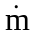 = ρ₁S₁v₁ = 900*0.049*3 =132.3 kg/s.

2.4. Crude oil of specific gravity 0.887 flows through the piping shown in figure T 2.3. Pipe A is 50 mm, pipe is 75mm and each of pipe C is 38 mm. An equal quantity of liquid flows through each of pipes C. The flow through pipe A is 6.65 m³/hr. Calculate (a) the mass flowrate in each pipe (b) the average linear velocity in each pipe and (c) the mass velocity in each pipe. ( mass velocity, G=mass/c/s area ).
A
B
C
C

Volumetric flow rate in A = 6.65 m³/hr.
∴ mass flow rate in A = 6.65*887 = 5898.55 kg/hr.
The mass flow rate through each of C is ½ of the total.
⇒ 5898.55/2 = 2949.275 kg/hr.
The velocity in pipe A = Q/S_{A}= 6.65/(2.165*10⁻³ *3600)=0.8532 m/s
The velocity in pipe B = Q/S_{B}= 6.65/(4.766*10⁻³ *3600)=0.3876 m/s
Velocity through each of C = Q/(2*S_{B}) = 6.65/(2*1.314*10⁻³ * 3600)= 0.7029m/s
The mass velocity through pipe A is G_{A} = /S_{A}
G_{A} = 5898.55/(2.165*10⁻³ *3600) = 756.81kg/m²s
G_{A} = /S_{B} = 5898.55/(4.766*10⁻³ *3600) = 343.79kg/m²s
G_{B} = /S_{B} =5898.55/(2*1.314*10⁻³ *3600) = 638.47kg/s

Bernoulli’s Equation (or ) Theorem
Statement : For potential flow, the total head at any cross section is constant. The total head consists of pressure head, velocity head (kinetic head) and datum head (potential head).
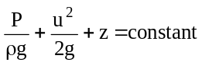
β
PΔS
Z
Z+ΔZ
(P+ΔP)ΔS
ΔL
ρgΔLΔS
Figure 2.3
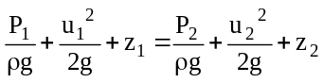
Consider a volume element of fluid flowing along a stream tube of constant cross section as shown in figure 2.3.
Let the cross-section of the stream tube be ΔS and average density of the fluid in the element is ρ. Let P and u are the pressure and velocity at the upstream end of the tube respectively. The pressure and velocity at the downstream end are P + ΔP and u+Δu respectively. Axis of the stream tube is making an angle β with vertical. The length of the volume element is ΔL. The time required for the volume element of fluid to move its own length ΔL is Δt.
Now consider the forces acting on the element.
The forces, which do act to accelerate or retard flow, are
- Force in the direction of flow = PΔS
- Force opposing the flow = (P + ΔP ) ΔS
- The component of force of gravity acting along the axis = ΔS ΔL g cos β
The resultant force in the direction of flow = PΔS -(P + ΔP ) ΔS- ρ ΔS ΔL g cos β
This force equals the mass of the volume element multiplied by its acceleration 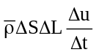
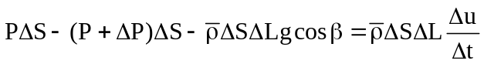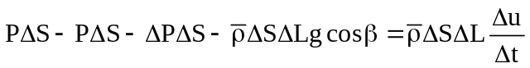
Dividing through out by ρΔSΔL gives 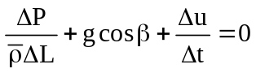
But from the figure 2.1
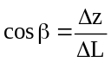and 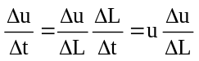
Substituting the value of cos β and Δu/Δt, we get
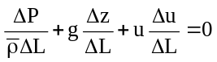
Now taking the limit of the terms in the above equation as ΔL approaches zero the ρ becomes ρ, we get the point form of Bernoulli’s equation or Euler’s equation
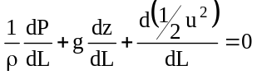
The differential form of the equation is
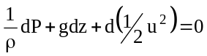
Case (i) : for incompressible fluids density is constant and the above equation can be integrated to give
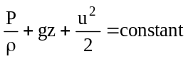
or in the head form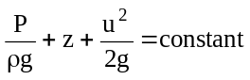
Between two definite points on the stream tube the above equation can be written as
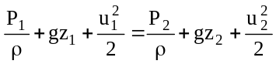
or in the head form,
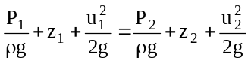
Modification of Bernoulli’s equation
For real fluids that are passing through pipe are influenced by the solid boundaries. To extend the Bernoulli’s equation to cover these practical situations two modifications are required. They are
- Fluid friction correction factor
- Kinetic energy correction factor
i. Fluid friction correction factor: Fluid friction correction factor can be defined as conversion of mechanical energy into heat in the flowing stream. So, in frictional fluid the total head is not constant along a stream line and always decrease in the direction of flow. In accordance with the principle of conservation of energy an amount of heat generated is equivalent to the loss in mechanical energy. So, for incompressible fluids, the bernoulli’s equation is corrected for friction by adding a term to the right hand side of the equation.
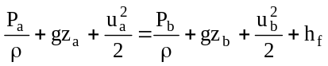, where h_{f} represents all the friction generated per unit fluid that occurs in the fluid between stations a and b.
Friction appears in boundary layers because the work done by shear forces in maintaining the velocity gradients in both laminar and turbulent flow is eventually converted into heat by viscous action. Friction generated in unseparated boundary layers is called skin friction. When the boundary layers separate and form wakes, additional energy dissipation appears within the wake and friction of this type is called form friction since it is a function of the position and shape of the solid. In a given situation both skin friction and form friction may be active in varying degrees. The total friction h_{f} in the above equation includes both types of frictional loss.

ii. Kinetic energy correction factor : Kinetic energy correction factor is defined as the ratio of the kinetic energy of the flow per second based on actual velocity across a section to the kinetic energy of the flow per second based on average velocity across the same section. It is denoted by α. Hence mathematically 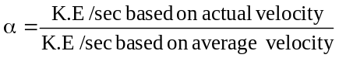
K.E/sec based on actual velocity across a section: Consider an element of cross-sectional area S. The mass flow rate through this is ρ u ds. Each kg of fluid flowing through area ds carries kinetic energy in amount u²/2 and the energy flow rate through area ds is therefore, 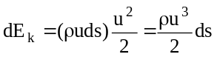, where E_{k} represents the time rate of flow of kinetic energy.
∴ the total rate of flow of kinetic energy through the entire cross section s , 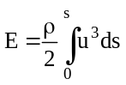.
But total rate of mass flow, 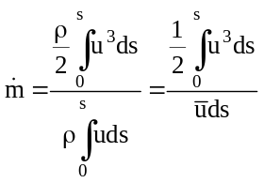,
so K.E/sec based on average velocity = 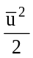
∴K.E. correction factor 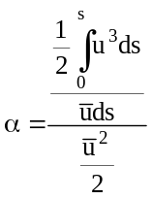 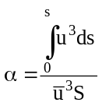

Worked Examples:
Problems with out friction
2.5. Water is flowing through a pipe of 5 cm diameter under a pressure of 2.943 * 10⁵N/m²(gauge) and with mean velocity of 2 m/s. Find the total head or total energy per unit mass of the water at a cross section which is 5 m above the datum line.
Data: Diameter of pipe = 5 cm = 0.05 m.
Pressure P = 2.943*10⁵ N/m²
Velocity v = 2 m/s
Datum head z = 5 m
∴Total head = pressure head + kinetic head + datum head
Pressure head = 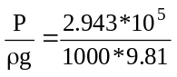=30m
Kinetic head = 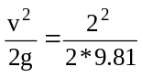=0.204m
Total head = 30+0.204+5=35.204m

2.6. A pipe through which water is flowing is having diameter 20cm and 10cm at the cross section 1 and 2 respectively. The velocity of water at section 1 is 4 m/s. Find the velocity head at section 1 and 2 and also rate of discharge.

Data:
D₁=20cm=0.20m | D₂=10cm=0.10m
S₁=(π/4)*D₁² = (π/4)*0.2² = 0.314m² | S₂=(π/4)*D₂² = (π/4)*0.1² = 0.00785 m²
v₁ = 4m/s | V₁ = ? m/s
Velocity head at section 1 = 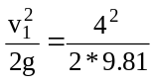=0.815m
We know from continuity equation for incompressible fluids that
S₁v₁ = S₂v₂ ⇒ 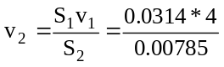=16m/s
Velocity head at section 2 = 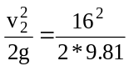=13.047m
Rate of discharge = S₁v₁ = 0.0314*4=0.1256 m³/s.

2.7. The diameter of a pipe changes from 20cm at a section 5m above datum, to 5m at section 3m above datum. The pressure of water at first section is 5*10⁵N/m². If the velocity of flow at the first section is 1m/s, determine the intensity of pressure at the second section.
Data:
D₁=20cm = 0.2m | D₂=5cm = 0.05m
S₁=(π/4)*D₁² = (π/4)*0.2² = 0.314m² | S₂=(π/4)*D₂² = (π/4)*0.05²= 1.96*¹⁰⁻³ m²
v₁ = 1m/s | v₂ = ?
P₁=5*10⁵N/m² | P₂ = ?
z₁₌ 5m | z₂ = 3m
We know from continuity equation for incompressible fluids that
S₁v₁ = S₂v₂ ⇒ 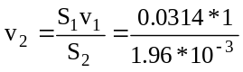=16.02 m/s
Applying Bernoulli’s equation between the sections 1and 2
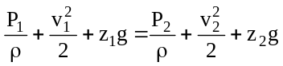
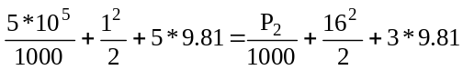
549.55=157.43+(P₂/1000)
Solving for P₂ from the above equation P₂ = 3.9212*10⁵N/m².
2.8. The water is flowing through a pipe having diameters 20cm and 10cm at section 1 and 2 respectively. The rate of flow through pipe is 35 lit/s. the section 1 is 6m above datum and section 2 is 4m above datum. If the pressure at section 1 is 3.924*10⁵N/m². Find the intensity of pressure at section 2.
Data:
D₁=20cm = 0.2m | D₂=5cm = 0.1m
S₁=(π/4)*D₁² = (π/4)*0.2² = 0.0314m² | S₂=(π/4)*D₂² = (π/4)*0.1²= 0.00782 m²
Q = 35lit/s=0.035 m³/s | v₂ = ?
P₁=3.924*10⁵N/m² | P₂ = ?
z₁₌ 6m | z₂ = 4m

Q=S₁v₁= S₂v₂ ⇒ 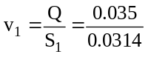=1.114 m/s
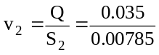=4.456 m/s
Applying Bernoulli’s equation between sections 1 and 2
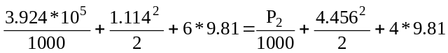
⇒ P₂ = 4.027*10⁵

2.9. Water is flowing through a pipe having diameter 30cm and 20cm at the bottom and upper end respectively. The intensity of pressure at the bottom end is 2.4525*10⁵ N/m² and the pressure at the upper end is 0.981*10⁵ N/m². Determine the difference in datum heat if the rate of flow through pipe is 40lit/s.
Data :
D₁=30cm = 0.3m | D₂=20cm = 0.2m
S₁=(π/4)*D₁² = (π/4)*0.3² = 0.0707m² | S₂=(π/4)*D₂² = (π/4)*0.2²= 0.0314 m²
Q = 40lit/s=0.040 m³/s | v₂ = ?
P₁=4.4525*10⁵N/m² | P₂ = 0.981*10⁵ N/m²
Q = 0.04m³/s = S₁v₁ = S₂v₂
⇒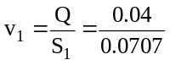=0.5658 m/s
⇒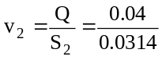=1.274 m/s
Applying Bernoulli’s equation interms of head
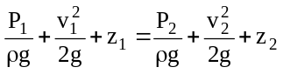
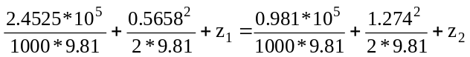
Solving for z₂-z₁= 14.93m

2.10. Water is flowing through a tapering pipe of length 100m having diameter 60cm at the upper end and 30cm at the lower end, at the rate of 50lit/s. The pipe has a slope of 1 in 30. Find the pressure at the lower end, if the pressure at the higher level is 1.962*10⁵N/m².
Data : Slope of the pipe (axis) is 1 in 30.
D₁=60cm = 0.6m | D₂=30cm = 0.3m
S₁=(π/4)*D₁² = (π/4)*0.6² = 0.2827m² | S₂=(π/4)*D₂² = (π/4)*0.3²= 0.07068 m²
Q = 50lit/s=0.050 m³/s | v₂ = ?
P₁=1.962*10⁵N/m² | P₂ = ? N/m²

Let the datum line pass through the center line of the lower end. i.e., z₂=0.
For every 30m length of pipe – height increases by 1m
∴for 100m of pipe 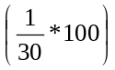=3.33m
Q = 0.05m³/s = S₁v₁ = S₂v₂
⇒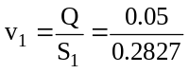=0.1768 m/s
⇒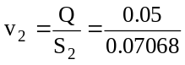=0.7074 m/s
Applying Bernoulli’s equation between upper and lower sections of pipe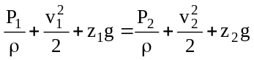
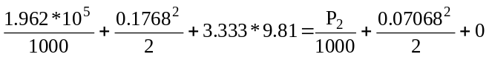
Solving for P₂= 2.28909*10⁵N/m²
2.11. A 5m long pipe in inclined at an angle of 15ºC with the horizontal. The smaller section of the pipe, which is at a lower level is of 80mm dia and the larger section of the pipe is of 240mm dia as shown in figure. Determine the difference of pressure between the two sections in N/m² if the pipe is uniformly tapered and the velocity of water at the smaller section is 1m/s.
15º
5sin15
5m

D₁=80mm = 0.08m | D₂=240mm = 0.24m
S₁=(π/4)*D₁² = (π/4)*0.08² = 0.005027m² | S₂=(π/4)*D₂² = (π/4)*0.24²= 0.042 m²
v₁= 1m/s | v₂ = ?
z₁=0m; z₂=0+5sinα = 5 sin15 = 1.294m.
We know from continuity equation for incompressible fluids that
S₁v₁ = S₂v₂ ⇒ 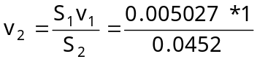=0.1112 m/s

Applying Bernoulli’s equation between the sections 1and 2
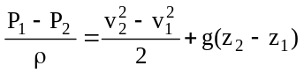
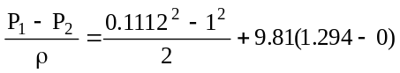
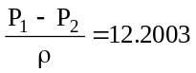
P₁-P₂ = 12200.32N/m² = 12.20032kN/m²

Problems with friction
2.12. A pipe of diameter 40cm carriers water at a velocity of 25m/s. The pressure, at the points A and B are given as 2.943*10⁵N/m² and 2.254*10⁵N/m² respectively, while the datum head at A and B are 28m and 30m. Find the loss of head between A and B.
Data: Diameter of pipe, d= 40cm =0.4m
Velocity, v = 25m/s
P_{A} = 2.943*10⁵ N/m² | P_{B} = 2.254*10⁵N/m²
z_{A} = 28m | z_{B} = 30m
Applying Bernoulli’s equation between sections A and B in head form
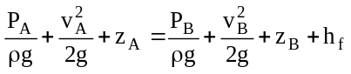
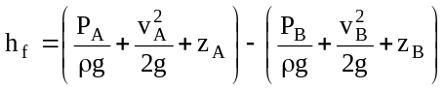
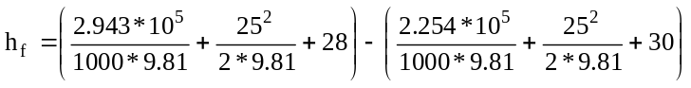
h_{f} = 5.023m of water. (loss in head)

2.13. A conical tube of length 2m is fixed vertically with its smaller end upwards. The velocity of flow at the smaller end is 5m/s while at the lower end it is 2m/s. The pressure head at the smaller end is 2.5m of liquid. The loss of head in the tube is 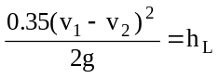, where v₁ is the velocity at the smaller end and v₂ at the lower end respectively. Determine the pressure head at the lower end. Flow takes place in the downward direction.
Data:Let upper end be 1 and lower end be 2; L=2m
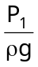=2.5m; v₁=5m/s; v₂=2m/s;
loss of head 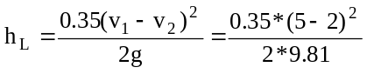=0.16m
Let the datum line pass through the section 2, Applying Bernoulli’s equation
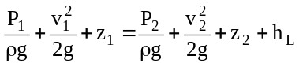
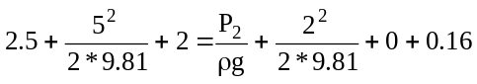
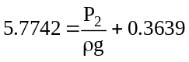
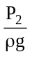=5.4103m of liquid.

2.14. A pipe line carrying oil of specific gravity 0.87 changes in diameter from 200mm diameter at a position A to 500mm at a position B which is 4m at a higher level. If the pressure at A andB are 0.981*10⁵N/m² and 0.5886*10⁵N/m² respectively, and the discharge is 200lit/s, determine the loss of head and direction of flow.
Data:
D_{A} = 200mm = 0.2m | D_{B} = 500mm =0.5m
S_{A}=(π/4)*D_{A}² = (π/4)*0.2² = 0.0314m² | S_{B}=(π/4)*D_{B}² = (π/4)*0.5²= 0.1963 m²
P_{A =} 0.981*10⁵ N/m² | P_{B =} 0.5886*10⁵ N/m²
Q = 200 lit/s = 0.2m³/s

Let the datum line pass through A
∴z_{A} = 0m and z_{B} = 4m.
we know 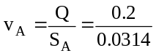=6.369m/s
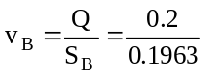=1.018m/s
A
B
z_{A}=0m
Z_{B}=4m
Applying Bernoulli’s equation between A and B
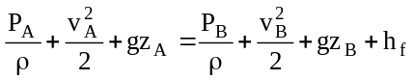

Solving for h_{f},
h_{f} = - 25.63J/kg.
The –ve sign signifies that the total energy at section B is greater than at section A. ∴the flow takes place from top to bottom (B to A).
The loss of energy h_{f} = 25.63J/kg =25.63/9.81m = 2.613m of liquid.

2.15. Brine (NaCl solution) of specific gravity 1.15 is draining from the bottom of a large open head tank through a 50mm pipe. The drain pipe ends at a point 4.57m below the surface of the brine in the tank. Considering a stream line starting at the surface of the brine in the tank and passing through the center of the drain line to the point of discharge and assuming the velocity of flow a long the stream line at the point of discharge from the pipe.
A
B
4.57m
Let the datum line passes through the point of discharge at point B
∴z_{B} = 0 and z_{A} = 4.57m
Let A be the surface of the liquid in the tank and B be the point of discharge.
Applying Bernoulli’s equation between points A and B
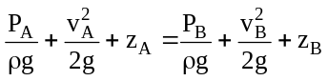
Velocity at point A will be very small because of the large cross-section of the tank and it can be neglected.
The pressure at A and B are equal because, both the points are exposed to atmosphere, ∴ both will have atmospheric pressure.
Finally Bernoulli’s equation simplifies to
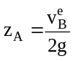 ⇒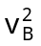= 2gz_{A} = 2*9.81*4.57 = 9.469m/s
Pump problems:
Work supplied to the pump from shaft work = w_{s}
Pump work = w_{p}
Total friction in the pump/kg of fluid = h_{fp}
Net mechanical energy available to the flowing fluid = w_{p} - h_{fp}
Pump efficiency η = w_{p} - h_{fp}/ w_{p}
∴ The mechanical energy delivered to the flowing fluid = ηw_{p}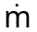
∴Power, P = ηw_{p}, watts or ηw_{p}/746, hp
Applying the bernoulli’s equation around the pump, the pressure drop developed by the pump is calculated as follows
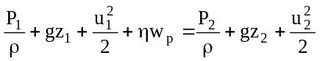, here z₁ = z₂ (as pump is parallel to datum line)
ū₁ = ū₂ (rate of flow is steady and dia of the pipe on suction side and delivery side are same )
∴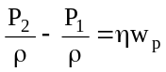
if ū₁ ≠ ū₂ 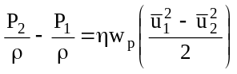

Problems on pumps
2.16. In the figure shown a pump draws a solution of specific gravity 1.84 from a storage tank through a 75mm pipe. The efficiency of the pump is 60%. The velocity in the suction line is 0.914m/s. The pump discharges through a 50mm pipe to an overhead tank. The end of the discharge pipe is 15m above the level of the solution in the feed tank. A frictional loss in the entire piping system is 30J/kg. What pressure must the pump develop and what is the power of the pump.
a
b
15m
Datum line
Let ‘a’ be the surface of the solution in the feed tank. ‘b’ be the discharge point.
From the figure z_{a} = 0 and z_{b} = 15m.
v_{a} is very small compared to v_{b} (due to large cross sectional area of the feed tank)
∴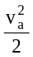can be neglected
Let the datum line passes through the surface of the liquid in the tank.
Pressures at both a and b will same, because both are opened to atmosphere.
Writing Bernoulli’s equation in energy form (because the frictional loss is given in the form of energy)
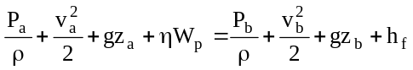, this equation reduces to the following equation after incorporating the above assumptions
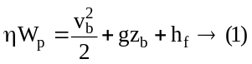
Diameter of suction pipe, D_{a}=0.075m
Diameter of delivery pipe, D_{b}=0.075m
Velocity in suction pipe, v_{a} = 0.914m/s
Area of suction pipe, S_{a} = (π/4)*D_{a}²=4.417*10⁻³ m².
Area of delivery pipe, S_{b} = (π/4)*D_{b}²=1.963*10⁻³ m².
We know from continuity equation that S_{a}v_{a} = S_{b}v_{b}
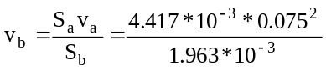=2.057m/s
Substituting v_{b} in equation (1), and solving
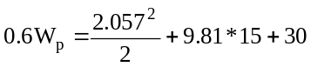⇒W_{p}=298.776J/kg.
Power, P = 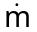w_{p}= ρ*v_{a}*S_{a}*W_{p}
P=1840*0.914*4.417*10⁻³ *298.776
P=2219.408 J/s = 2219.408W

P = 2.219kW

To find the pressure drop developed across the pump, let
1 be input to the pump and 2 be output from the pump
from the figure z₁ ≈ z₂.
Applying Bernoulli’s equation across points 1 and 2,
1
P₁
2
P₂
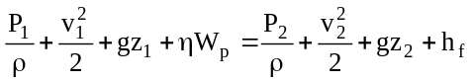,
here h_{f}, because there is no piping system for the loss of head/energy in the pipe.
∴ Bernoulli’s equation reduces to
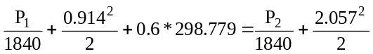
solving for P₂-P₁, we get
P₂-P₁ = 3.267*10⁵N/m²

2.17. Water at 25ºC is pumped at a constant rate of 24*10⁻⁴m³/s from a large reservoir resting on the floor to the top of an experimental absorption tower. The point of discharge is 5m above the floor and the frictional loss in the 0.05m pipe from the reservoir to the tower amounts to 2.4J/kg. At what height in the reservoir must the water level be kept if the pump can develop only 100 watts.
ρ_{water} =1000 kg/m³
a
b
Z_{b}=5m
ABSORBER
Datum line
Z_{a}
Floor is taken as datum line. Let station ‘a’ be the surface of the water in the reservoir and ‘b’ the discharge point.
Applying Bernoulli’s equation between station a and b
The velocity v_{a} in the reservoir will be very small and can be neglected. The pressure P_{a} and P_{b} is atmospheric. So they get cancelled out.
We know Power, P=W_{p} = 100W ⇒ W_{p} = 100/
Where =Q*ρ=24*10⁻⁴*1000=2.4kg/s ⇒ W_{p} = 100/2.4 = 41.67J/kg
Area of the delivery pipe S_{b}= (π/4)*d²=(π/4)*0.05² = 1.96*10⁻³m²
∴v_{b}=Q/S_{b} = (24*10⁻⁴)/(1.96*10⁻³) = 1.22m/s
Assuming an efficiency of 60%, z_{b}=5m and h_{f}=2.4J/kg
Substituting above values in Bernoulli’s equation
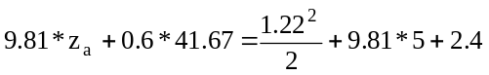 ⇒ z_{a}=2.77m
A height of atleast 2.77m should be maintained in the feed tank for the given operation.
2.18. Oil of specific gravity 0.75 is pumped from a tank over a hill through a 60cm pipe with the pressure at the top of the hill maintained at 1.75*10⁻³N/m². The summit of the hill is 80m above the surface of the oil in the tank and oil is pumped at the rate of 0.6m³/s. If the lost head from the tank to summit is 5m, what HP must the pump supply to the liquid?
a
b
80m
Datum line
Data :P_{b} = 1.75*10³N/m².
P_{a} = 1.01325*10⁵N/m² (atmospheric)
h_{f} = 5m = 5*9.81 = 49.05J/kg
Let the station ’a’ be the surface of the oil in the reservoir and station ‘b’ be the discharge point. Let the datum line pass through the surface of the oil.
⇒ z_{a} = 0; z_{b} = 80m
Discharge, Q=0.6m³/s; diameter of pipe =0.6m
Area of pipe, S_{b} = (π/4)*0.6² = 0.283m².
v_{b}= Q/S_{b} = 0.6/0.283 =2.12m/s
v_{a} is very small, because of the larger cross-section of the reservoir, ∴ 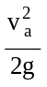 can be neglected.
Applying Bernoulli’s equation
ηW_{p} = 703.33 J/kg
Power, P=ηW_{p}
=Qρ = 0.6*750=450 kg/s
P = 450 * 703.33 = 314498.5 W
P = 314498.5/746 = 424.26 HP
2.19. A pump feeds 10000kg/hr of nitrobenzene at a temperature of 20ºC from a tank to a reactor which is 15m above the level of nitrobenzene in the tank. Find the power consumed by the pump assuming an efficiency of 0.6, diameter of the pipe is 8cm. Density of nitrobenzene is 1200kg/m³. Viscosity, μ = 0.0021PaS. Length of the pipe is 200m. For the given system under the given arrangement the relationship between velocity and the friction factor is given by f=0.005v ^{-0.25}, where f is the friction factor and v is the velocity in m/s. Given 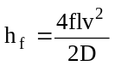
a
b
15m
Datum line
Let the datum line pass through the surface of nitrobenzene.
Let ‘a’ be the point on the surface of nitrobenzene and ‘b’ be the point of discharge.
Data: z_{a}=0; z_{b} = 15m
Mass flow rate, = 10000kg/hr
=10000/3600 = 2.78kg/s
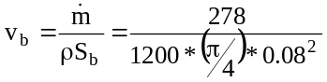=0.461m/s
f= 0.005 v^{-0.25} = 0.005* 0.461^{-0.25} = 6.068*10⁻³
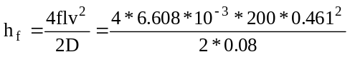=6.45 J/kg
Applying Bernoulli’s equation
The pressures at stations a and b are at atmospheric pressure, because they are exposed to atmosphere. The velocity in the feed tank can be neglected because of the large cross section of the tank.
∴Bernoulli’s equation reduces to
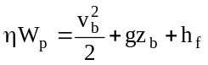
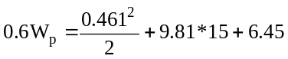
W_{p} = 265.177J/kg
Power, P = W_{p} = 2.76*256.177 = 711.6W

P = 711.6/746 = 0.956HP ≈1HP (this is the power of the pump)
FLOW OF INCOMPRESSIBLE FLUIDS IN PIPES
Shear stress distribution in a cylindrical tube :
R
r
P₁
P₂
Δx
τ
A
B
C
D
Figure 2.4
Consider a horizontal pipe of radius R in which a steady flow of a viscous fluid at constant density is taking place. Visualize a disk shaped element of fluid, concentric with the axis of the tube of radius r and length Δx as show in figure. Assume the element is isolated as a feed body. Let the fluid pressure on the upstream and downstream faces of the disk be (ie., faces AB and CD ) P₁and P₂ respectively. Since the fluid posses a viscosity, a shear force opposing the flow will exist on the rim of the element.
Then the forces acting on the fluid element are
- the pressure force, P₁ (πr²) on the face AB
- the pressure force, P₂(πr²) on the face CD
- the shear force τ ( 2πrΔx) on the surface of fluid element.
As there is no acceleration, the summation of all forces in the direction of flow must be zero
i.e., P₁ πr² – P₂ πr² - τ 2πrΔx = 0
(P₁-P₂)πr² - τ2πrΔx = 0
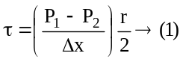The shear stress, τ across a section varies with r as 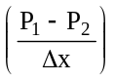is constant. Hence shear stress distribution across a section is linear as shown in the
figure 2.5.
τ
Figure 2.5. Shear stress distribution

Velocity distribution across a section
We know 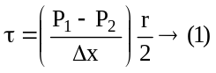 from shear stress distribution, and also from Newton’s law of viscosity 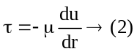
Equating (1) and (2)
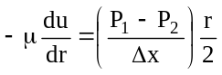
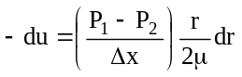, integrating with respect to r gives
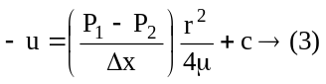, where c is the integration constant and its value is obtained from the boundary conditions i.e., at r= R ; u=0
∴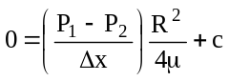
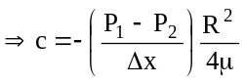, substituting the value of c in the equation (3)
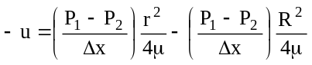
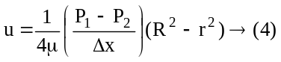
In the above equation the values of μ, 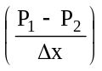and R are constants, which means that the velocity u varies with the square of r. This shows that the velocity distribution across the section of a pipe is parabolic. This velocity distribution is shown in figure 2.6

Ratio of maximum velocity to average velocity
The velocity is maximum when r=0.
Thus maximum velocity, 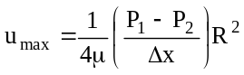
The average velocity ū is obtained by dividing the discharge of the fluid across the section by the area of the pipe. The discharge, Q across the section is obtained by considering the flow through a circular ring element of radius r and thickness dr.
Figure 2.6. Velocity distribution in a circular conduit
r
dr
R

∴The fluid flowing per second through this elementary ring is
dQ=velocity at a radius r x area of the ring element
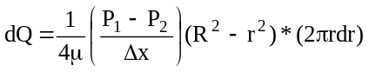
integrating
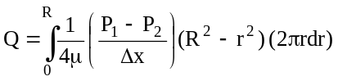
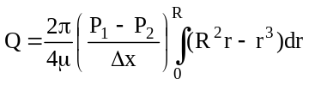
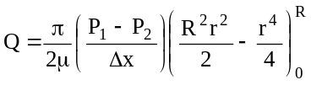
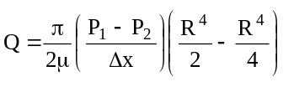
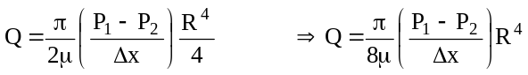
∴ Average velocity, ū = Q/A
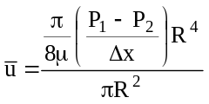
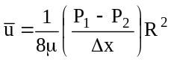
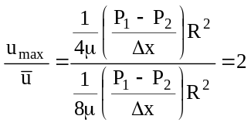
∴ The ratio of maximum velocity to average velocity is 2
if (i) the flow is laminar flow
(ii) the fluid is newtonian fluid and
(iii) the flow takes place through a circular conduit.
Pressure drop for a given length of pipe (Δx=L)
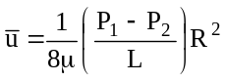
8μūL=(P₁-P₂)R²
P₁-P₂=8μūL/R²
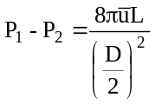
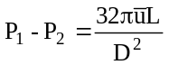, This is the pressure drop across a length of pipe L.
∴ Head loss, 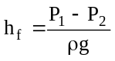
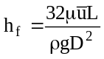, This equation is called Hagen – Poiseuille equation.
Worked Examples
2.20. Medium lubricating oil of relative density 0.86 is pumped through 305m of horizontal pipe having a diameter of 50 mm at the rate of 1.23x10⁻³m³/s. If the drop in pressure is 207 kN/m². Determine the absolute viscosity of oil assuming the flow to be laminar.
Sol: Given Q=1.23x10⁻³m³/s
D= 50 mm = 0.05m.
A = πD²/4=π (0.05)²/4=1.963x10⁻³m².
Ū=Q/A = 1.23x10⁻³/1.963x10⁻³ = 0.626m/s
ΔP=32μūL/D²
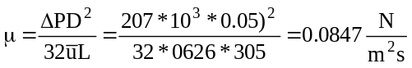
2.21. A laminar flow is taking place in a pipe of diameter of 20 cm. The maximum velocity is 1.5m/s. Find the mean velocity and the radius at which this occurs. Also calculate the velocity at 4 cm from the wall of the pipe.
Sol : ū = ½ u_{max} = ½ * 1.5 =0.75m/s
We have 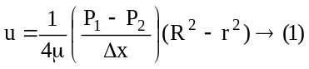
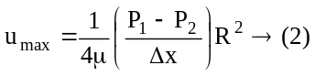
Dividing [1] by [2]
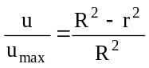, substituting u as ū and solving for r, gives r = 0.0707m.
Again 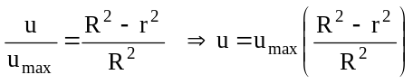
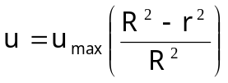=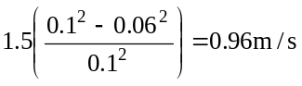
2.22. A crude oil of viscosity 0.97 poise and relative density 0.9 is flowing through a horizontal circular pipe of diameter 10 cm and of length 10m. Calculate the difference of pressure at the two ends of the pipe if 100kgs of the oil is collected in a tank in 30 seconds.
Sol: μ=0.97poise = 0.097 Ns/m²
ρ= 0.9*1000=900 kg/m³
D= 10 cm = 0.1m
L= 10m
m=100/30 = 3.33kg/s
Q= 3.33/900 = 3.7037*10⁻³ m³/s
ū = Q/A = 3.7037 *10⁻³/(π* 0.1²/4)
ū=0.4715m/s
P₁ - P₂ = 32μūL/D² = 32*0.097*0.4715*10/0.1²
P₁ - P₂ =1463.75 N/m².

2.23. The velocity distribution in a pipe 25 mm diameter and 10m long in which the flow is laminar is given by u_{r} = 2- c r², where u_{r} is the velocity in m/s at any radius r and c is a constant. Determine (a) Rate of flow in lit/s (b) average velocity in m/s (c) maximum velocity in m/s (d) shear force at the pipe wall per m of pipe length in N (e) units of C and its value (f) the radial position at which a pitot tube be placed to measure the average velocity. Viscosity μ =0.001 N.s/m².
Sol : maximum velocity occurs when r =0
∴ u_{r} = 2- c r², when r = 0 ; u_{max} = 2 m/s (sol. for (c))
for laminar flow in a circular pipe ū/u_{max} = 0.5
∴ ū = 0.5 u_{max} = 0.5 *2 =1m/s (sol. for (b))
Rate of flow Q= ū* S = 1* (/4)* D² = 4.9087*10⁻⁴ m³/s
Q =0.49087 lit/s (sol. for (a))
From Hagen – poiseuillies equation
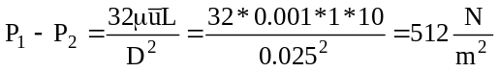
we know 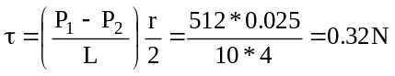(sol. for (d))
When r =R, u_{r} = 0
i.e., 0=2 – c R² ⇒ c = 2/R² = 12800 m⁻¹s⁻¹ (sol. for (e))
we know 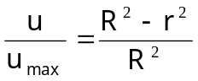 or
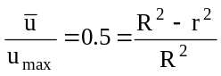, solving for r we get
r = 8.83 * 10⁻³m

2.24. What power is required per kilometer of a line to overcome the viscous resistance to the flow of glycerine through a horizontal pipe of diameter 10cm at the rate of 10lit/s. Take μ=8P and kinematic viscosity 6 stokes.
Data: Q=10lit/s = 0.01m³/s
D = 10cm = 0.1m ⇒ S = (π/4)*0.1² = 0.00785 m²
V = Q/S = 0.01/0.00785 =1.27m/s
From Hagen-Poiseullie’s 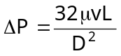
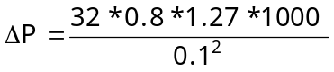=3251200N/m²
Power, 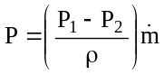=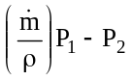
⇒P = (P₁-P₂)* Q = 3251200*0.01 =32512W = 43.58HP
Viscous (Laminar) flow between two parallel plates
Y
2y
dy
Δx
P₁
P₂
A
B
C
D
P₁
P₂
τ
τ
τ
τ
Figure 2.7. Flow between two parallel plates
Consider two parallel plates kept at a distance Y m apart as shown in the figure 2.7. A viscous fluid is flowing between these two plates from left to right. Consider a fluid element of length Δx m, width Δz m and thickness 2y m. If P₁ is the intensity of pressure on the face AB then the intensity of pressure on face CD will be P₂.
Then the forces acting on the fluid element are
- The pressure force, F₁ = P₁2yΔz
- The pressure force, F₂ = P₂2yΔz
- The shear force on the face AD F₃ = τ Δx Δz
- The shear force on the face BC F₄ = τ Δx Δz
As there is no acceleration the summation of all forces in the direction of flow must be zero.
i.e., F₁ – F₂ – F₃ – F₄ = 0
P₁ 2y Δz – P₂ 2y Δz - τ Δx Δz - τ Δx Δz = 0
(P₁ – P₂ ) 2y - 2τ Δx = 0
⇒ 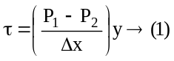
The shear force τ across the section varies with y as (P₁-P₂)/Δx is constant. Hence shear stress distribution is linear as shown in figure 2.8.
τ
Figure 2.8. Shear stress distribution
Velocity distribution across the section
We have 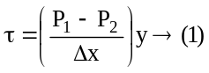 and also 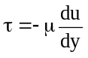 from Newton’s law of viscosity. ∴ equating the both equations gives
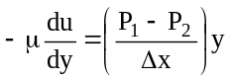
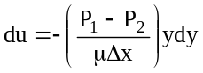 , Integrating the above equation gives
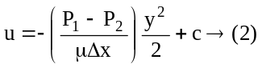
where c is integration constant and its value is obtained from the boundary conditions; when y = Y/2, u=0
∴(2) ⇒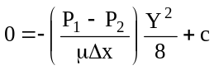
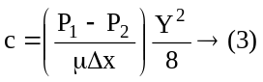
substituting the value of c from equation(3) in (2)
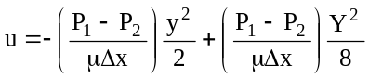
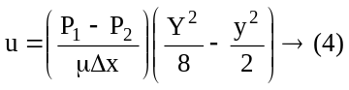
In equation (4) the values of μ, (P₁-P₂)/Δx and Y are constants, which means that u varies with the square of y. This shows that the velocity distribution across the section of a pipe is parabolic. This velocity distribution is shown in figure 2.9.
Figure 2.9. Velocity distribution
Ratio of maximum velocity to average velocity
Velocity is maximum when y = 0.
∴ 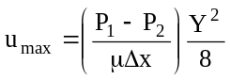
The average velocity ū is obtained by dividing the discharge of the fluid across the section by the area.
i.e., ū=Q/S
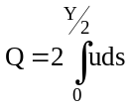
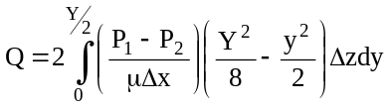
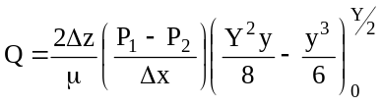
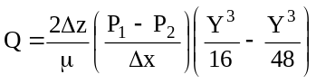
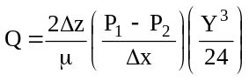
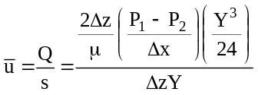
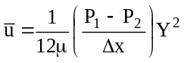
∴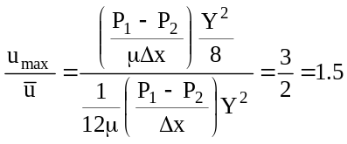
Drop of pressure head for a given length
or
P₁ – P₂ = 12μΔxū/Y²
∴h_{f} = (P₁ – P₂)/ρg = (12μΔxū)/ρg Y²

Worked Examples
2.25. An oil of viscosity 10P flows between two parallel fixed plates which are kept at a distance of 5cm apart. Find the rate of flow of oil between the plates, if the drop of pressure in a length of 120cm be 0.3N/cm². The width of the plate is 20cm.
Data : Y=5cm = 0.05m
ΔP=0.3N/cm² = 0.3*10⁴ =3000N/m²
Δx = 120cm =1.2m
width Z = 20cm =0.2m
we know 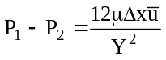, solving for 
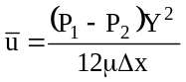
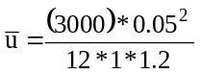=0.52m/s
Q= S = 0.52*(0.05*0.2) = 0.0052m³/s

2.26. There is a horizontal crack of 4 cm wide and 2.5mm deep in a wall of thickness 10cm. Water leaks through the crack. Find the rate of leakage through the crack if the difference of pressure drop between the two ends of the crack is 0.02943 N/cm². Viscosity of water is 0.01P.
Data : P₁-P₂ = 0.02943N/cm² = 0.02943*10⁴= 294.3N/m²
Y=2.5mm = 2.5*10⁻³
Δx=10cm = 0.1m
Δz=4cm =0.04m
we know , solving for 
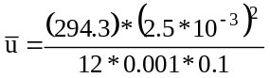=1.532m/s
Q= S = 1.532*(0.04*2.5*10⁻³) = 1.532*10⁻⁴m³/s

2.27. Determine the pressure gradient, shear stress at the two horizontal parallel plates and the discharge per meter width for laminar flow of oil with a maximum velocity of 2m/s between two horizontal plates which are 10cm apart. Given μ=2.4525Ns/m².
Data : P₁-P₂ = ?
Y=10cm = 0.1m
Δx=10cm = 0.1m
Δz=4cm =0.04m
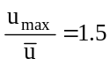
⇒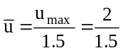=1.33m/s
we know 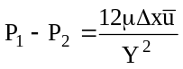
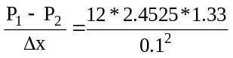=3924N/m²per meter length of pipe
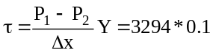=329.4N/m²
Q = S = 1.33*1*0.1=0.133m³/s
HEAD LOSS IN TURBULENT FLOW DUE TO FRICTION
Consider a horizontal pipe of radius R. The turbulent fluid flow is taking place in the pipe from left to right as shown in figure 2.10. Let P₁ and P₂ be the intensity of the pressure at sections 1-1 and 2-2 respectively. Let sections 1-1 and 2-2 are separated by a length L.
Then the forces acting on the fluid element are
1
1
2
2
P₁
P₂
F
F
L
Figure 2.10. Friction in turbulent flow
- The pressure force at section 1-1, F₁ = P₁S
- The pressure force at section 2-2, F₂ = P₂S
- The frictional resistance force, F₃ = F p L
Where S is the cross sectional area of the pipe
p is the wetted perimeter = πD (if the pipe is running full).
As there is no acceleration, the summation of all forces in the direction of the flow must be equal to zero
P₁ S – P₂ S – F pL = 0
(P₁ – P₂) S = F p L
It was found by Darcy that the frictional resistance force per unit area is proportional to kinetic energy of fluid per unit volume
i.e., 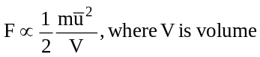
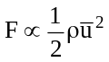 ;
F = f ½ ρū², where f is the proportionality factor called friction factor
(P₁ – P₂) S = f ½ ρū² p L
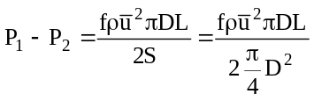
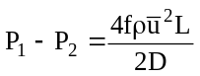
∴ 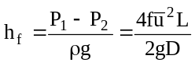, This equation is known as Darcy-weisbatch equation.
Relation between f and N_{re}
We have 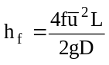, from Darcy-weisbatch equation and
, from Hagen – Poiseuille equation.
Equating both the equations and solving for f
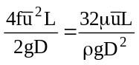
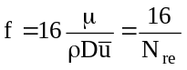

Worked Examples
2.28. An oil discharges from a large constant head tank through a horizontal round cast iron pipe 10m long at the rate of 16*10³ kg/min. The tank and the tube are placed at the same level. The specific gravity and the kinematic viscosity of oil are 0.85 and 6*10⁻⁶ m²/s respectively. If the head loss does not exceed 2m per 100m, find the diameter of the pipe and also determine the average velocity of oil flowing in the pipe. Take f=0.0035 for this flowrate.
Sol: h_{f} = 0.2 m ( because 2m per 100 m ⇒ 0.2 m per 10m)
ρ = 850 kg/m³, γ = 6*10⁻⁶ m²/s ⇒ γ = μ/ρ = 6*10⁻⁶ m²/s
μ = γ*ρ = 6*10⁻⁶ * 850 = 0.051 Ns/m²
m = 16*10³ kg/min = 16*10³ /60 kg/s = 266.67 kg/s
Q= m/ρ = 266.67/850 = 0.3137 m³/s
ū = Q/S = 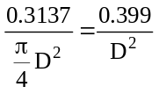
we know , substituting the value of ū, we get
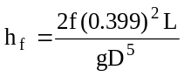, solving for D, we get
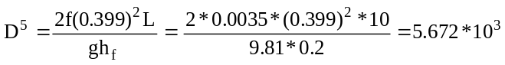
D = 0.355m
∴ ū = Q/S = 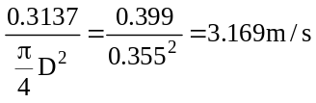
2.29. Calculate the friction factor when water is flowing under laminar conditions in a pipe of 1 cm diameter and at a velocity of 10 cm/s.
Sol : for laminar flow , f=16/N_{re}
and N_{re} = ρDū/μ = 1000*0.01*0.1/0.001 = 1000
∴ f = 16/1000 = 0.016

Turbulent flow in pipe and closed channels
In flow of fluid through a closed channel turbulence cannot exist permanently at the boundary between the solid and the flowing fluid. The velocity at the interface is zero because of the adherence of the fluid to the solid. It is probable that within a thin volume immediately adjacent to the wall, eddies seldom occur. This layer is called the viscous sub layer. The thickness of the viscous sub layer at any point must be (widely) fluctuating as a result of the impact of eddies of various sizes from adjacent fluid. Within the viscous sub layer only viscous shear is important, and eddy diffusion, if present at all, is minor. The viscous sub layer occupies a very small fraction of the total cross section of the stream, and the remaining stream is in turbulent flow. A transition layer exists immediately adjacent to the viscous sub layer in which both viscous shear and shear due to eddy diffusion exist. Transition layer, which is sometime called a buffer layer, also is relatively thin. The bulk of the cross section of the flowing stream is occupied by flow which is entirely turbulent and which is called the turbulent core.
Relation between maximum velocity and average velocity for turbulent flow
The quantities N_{re} and ratio ū/u_{max} are useful in relating the average velocity to the maximum velocity in the centre of the tube as a function of flow conditions. An important method of measuring fluid flow is the pitot tube, which can be used to measure u_{max}, and this relationship is then used to determine the average velocity from this single observation.
For laminar flow ū/u_{max} is exactly 0.5. The ratio changes rapidly from 0.5 to about 0.8 when laminar flow changes to turbulent flow.
Hydraulically smooth pipe: In turbulent flow a rough pipe leads to a larger friction factor for a given Reynolds number than a smooth pipe does. If a rough pipe is smoothed, the friction factor is reduced. When further smoothing brings about no further reduction in friction factor for a given Reynolds number, the tube is said to be hydraulically smooth. Figure 2.11 shows several idealized kinds of roughness.
The height of a single unit of roughness is denoted by k and is called roughness parameter. From dimensional analysis, f is found to be a function of both N_{re} and the relative roughness k/D, where D is the diameter of pipe. For a given kind of roughness, for eg. that shown in figure 2.11, it can be expected that a different family of curve

